CSA 0208 – C Programming
AUTOMOBILE SERVICE CENTRE MANAGEMENT SYSTEM
Submitted by
Abhidhya Sri Mailsamy Sumitha (192520051)
P Deekshitha (192412104)
Problem Statement
An automobile service centre attends many automobiles each day. Information that needs to be maintained at an automobile service centre includes customer information, automobile information, services provided on that automobile, date of services provided, cost of the spare-parts used, labour cost and total bill. Using a manual service register, this information is usually captured in a notebook or a paper form. Capturing information manually brings in numerous drawbacks such as difficulty in searching for a specific automobile, calculation errors, duplication, loss of data, difficulty in updating services, human errors among others. Generation of daily service report and identification of high cost services also becomes difficult in case of increasing number of automobiles.
To solve these drawbacks, a computerized automobile service centre management system will be developed using the C programming language. The system captures vehicle and customer information using structures and presents a menu driven interface through which the service-centre staff can perform various operations. The system enables registration of an automobile, searching, update of service, billing of services, sorting of automobiles according to the cost of services and filtering of automobiles above a specific cost threshold. Daily service report generation and permanent storage of records using file handling is also possible in the application. The application also includes provision of validation and error handling for duplicate vehicle number, cost, date, maximum record limit, file open and invalid user choice errors.
This system shows various concepts in C programming such as structure, array, pointer, function, searching, sorting, file handling, conditional statement, loop and validation. The application is designed to be simple enough to operate a small service center while still laying a strong foundation for a larger real-world service management application.

Objectives
A major objective of the Automobile Service Centre Management System is to come up with a dependable and user-friendly C program for managing the automobile services records. This will involve replacing the manual process of recording service information with computerization of the whole process through storing and retrieving the service information effectively. The other aim of the application is to illustrate the actual use of structures and pointers in C programming. This involves using the structure to encapsulate all vehicle service record information together while using pointers to the structures to allow the passing of records as arguments to functions and their manipulation directly. The other aim of the application is to illustrate file management where service records are stored permanently while loading automatically upon starting the application.
Proper input validation and runtime error handling is another important aim of the program. This involves the exclusion of duplicate vehicle numbers since a vehicle must have its own unique service record number. Non numeric or negative service cost should also not be allowed while wrong dates of service should not be accepted. Moreover, the program should not allow users to insert records after reaching the maximum record capacity.

Scope of the Project
The scope of the intended Automobile Service Centre Management System entails the management of basic data about car services in a small or medium size automobile service center. The application contains customer data, vehicle details, service type, date of service, price of parts, labor costs, and total cost of service. The system is capable of performing a number of operations on these records through the menu.
The present system is capable of storing up to 100 records by use of a fixed sized array. This restriction makes the program simple enough and easy to demonstrate C programming skills. The system is also able to store the records in binary files in order to ensure that the records are not lost upon closing of the application. Future scope of the system will include support for larger databases, user authentication, service booking, inventory management, automated invoicing, SMS notification and GUIs.

Requirements of the environment used
This system is implemented using the C programming language due to its direct support for structures, pointers, arrays, functions, memory allocation and file operations which makes C a good candidate for showcasing programming constructs needed in the given task. The application could be compiled with GCC or any other standard C compiler. The development process could also be done on any development environment like Code::Blocks, Dev-C++ or Visual Studio Code or similar environment.
The minimum software requirement includes a standard C compiler that has support for standard C libraries since the program uses standard C libraries including stdio.h for I/O and file manipulation, stdlib.h for various utilities, string.h for string manipulation, and ctype.h for character validation. The hardware requirements are also very minimal as the application does not have any graphical user interface and uses only a few records of service data. A regular computer or laptop running a standard OS should suffice to run the application.
The service records are stored in the binary file named service_records.dat which will be automatically opened to load records at the start of the program and save records either in the middle of execution or exit of the program.

Proposed System Design
The proposed system follows a modular design in which each major operation is implemented as a separate function. The central data structure is ServiceRecord, which contains all information associated with one service transaction. An array named records stores multiple service records, while recordCount maintains the number of currently stored records.
The program starts by loading existing records from the binary file. It then presents a main menu to the user. Based on the selected option, the corresponding function is called. For example, selecting registration calls the vehicle-registration function, while selecting search calls the search function. This modular approach makes the program easier to understand, test, debug, and maintain.
The system also uses a unique vehicle number to identify records. Before a new record is inserted, the program searches for the vehicle number in the existing array. If the number already exists, registration is rejected. This prevents duplicate service records for the same vehicle.

Implementation
#include <stdio.h>
#include <stdlib.h>
#include <string.h>
#include <ctype.h>

#define MAX_RECORDS 100
#define FILE_NAME "service_records.dat"

struct ServiceRecord {
char vehicleNumber[20];
char customerName[50];
char vehicleModel[30];
char serviceType[30];
char serviceDate[15];

float partsCost;
float labourCost;
float totalServiceCost;
};

struct ServiceRecord records[MAX_RECORDS];
int recordCount = 0;

/* Function Prototypes */
void registerVehicle();
void searchVehicle();
void updateServiceDetails();
void calculateTotalBill();
void sortByServiceCost();
void displayHighCostServices();
void dailyServiceSummary();
void saveRecords();
void loadRecords();

void calculateCost(struct ServiceRecord *record);
void displayRecord(struct ServiceRecord *record);
int findVehicle(const char vehicleNumber[]);
int isValidDate(const char date[]);
int isValidCost(float cost);

void clearInputBuffer();
void readString(char str[], int size);
void mainMenu();

/* Clear unwanted input */
void clearInputBuffer()
{
int c;

while ((c = getchar()) != '\n' && c != EOF);
}

/* Read string safely */
void readString(char str[], int size)
{
fgets(str, size, stdin);

str[strcspn(str, "\n")] = '\0';
}

/* Validate cost */
int isValidCost(float cost)
{
if (cost < 0)
return 0;

return 1;
}

/* Validate date in DD-MM-YYYY format */
int isValidDate(const char date[])
{
int day, month, year;

if (strlen(date) != 10)
return 0;

if (date[2] != '-' || date[5] != '-')
return 0;

if (!isdigit(date[0]) || !isdigit(date[1]) ||
!isdigit(date[3]) || !isdigit(date[4]) ||
!isdigit(date[6]) || !isdigit(date[7]) ||
!isdigit(date[8]) || !isdigit(date[9]))
return 0;

sscanf(date, "%d-%d-%d", &day, &month, &year);

if (year < 2000 || year > 2100)
return 0;

if (month < 1 || month > 12)
return 0;

if (day < 1 || day > 31)
return 0;

return 1;
}

/* Find vehicle using vehicle number */
int findVehicle(const char vehicleNumber[])
{
int i;

for (i = 0; i < recordCount; i++)
{
if (strcmp(records[i].vehicleNumber, vehicleNumber) == 0)
return i;
}

return -1;
}

/* Calculate total service cost using pointer */
void calculateCost(struct ServiceRecord *record)
{
record->totalServiceCost =
record->partsCost + record->labourCost;
}

/* Display one service record */
void displayRecord(struct ServiceRecord *record)
{
printf("\n----------------------------------------\n");
printf("Vehicle Number : %s\n", record->vehicleNumber);
printf("Customer Name : %s\n", record->customerName);
printf("Vehicle Model : %s\n", record->vehicleModel);
printf("Service Type : %s\n", record->serviceType);
printf("Service Date : %s\n", record->serviceDate);
printf("Parts Cost : Rs. %.2f\n", record->partsCost);
printf("Labour Cost : Rs. %.2f\n", record->labourCost);
printf("Total Cost : Rs. %.2f\n", record->totalServiceCost);
printf("----------------------------------------\n");
}

/* Register a vehicle */
void registerVehicle()
{
struct ServiceRecord *record;

if (recordCount >= MAX_RECORDS)
{
printf("\nERROR: Maximum record capacity reached!\n");
printf("Cannot register another vehicle.\n");
return;
}

record = &records[recordCount];

printf("\n========== REGISTER VEHICLE ==========\n");

printf("Enter Vehicle Number: ");
readString(record->vehicleNumber, sizeof(record->vehicleNumber));

/* Duplicate checking */
if (findVehicle(record->vehicleNumber) != -1)
{
printf("\nERROR: Vehicle number already exists!\n");
printf("Registration cancelled.\n");
return;
}

printf("Enter Customer Name: ");
readString(record->customerName, sizeof(record->customerName));

printf("Enter Vehicle Model: ");
readString(record->vehicleModel, sizeof(record->vehicleModel));

printf("Enter Service Type: ");
readString(record->serviceType, sizeof(record->serviceType));

/* Date validation */
do
{
printf("Enter Service Date (DD-MM-YYYY): ");
readString(record->serviceDate, sizeof(record->serviceDate));

if (!isValidDate(record->serviceDate))
{
printf("ERROR: Invalid date format or date value!\n");
printf("Please use DD-MM-YYYY.\n");
}

} while (!isValidDate(record->serviceDate));

/* Parts cost validation */
do
{
printf("Enter Parts Cost: ");

if (scanf("%f", &record->partsCost) != 1)
{
printf("ERROR: Please enter a valid number.\n");
clearInputBuffer();
record->partsCost = -1;
}
else
{
clearInputBuffer();

if (!isValidCost(record->partsCost))
printf("ERROR: Cost cannot be negative.\n");
}

} while (!isValidCost(record->partsCost));

/* Labour cost validation */
do
{
printf("Enter Labour Cost: ");

if (scanf("%f", &record->labourCost) != 1)
{
printf("ERROR: Please enter a valid number.\n");
clearInputBuffer();
record->labourCost = -1;
}
else
{
clearInputBuffer();

if (!isValidCost(record->labourCost))
printf("ERROR: Cost cannot be negative.\n");
}

} while (!isValidCost(record->labourCost));

calculateCost(record);

recordCount++;

printf("\nVehicle registered successfully!\n");
printf("Total Service Cost: Rs. %.2f\n",
record->totalServiceCost);
}

/* Search vehicle */
void searchVehicle()
{
char vehicleNumber[20];
int index;

printf("\n========== SEARCH VEHICLE ==========\n");

printf("Enter Vehicle Number: ");
readString(vehicleNumber, sizeof(vehicleNumber));

index = findVehicle(vehicleNumber);

if (index == -1)
{
printf("\nVehicle not found!\n");
}
else
{
printf("\nVehicle Found!\n");
displayRecord(&records[index]);
}
}

/* Update service details */
void updateServiceDetails()
{
char vehicleNumber[20];
int index;

printf("\n========== UPDATE SERVICE ==========\n");

printf("Enter Vehicle Number: ");
readString(vehicleNumber, sizeof(vehicleNumber));

index = findVehicle(vehicleNumber);

if (index == -1)
{
printf("\nVehicle not found!\n");
return;
}

printf("\nCurrent Record:");
displayRecord(&records[index]);

printf("\nEnter New Service Type: ");
readString(records[index].serviceType,
sizeof(records[index].serviceType));

do
{
printf("Enter New Service Date (DD-MM-YYYY): ");
readString(records[index].serviceDate,
sizeof(records[index].serviceDate));

if (!isValidDate(records[index].serviceDate))
printf("ERROR: Invalid date!\n");

} while (!isValidDate(records[index].serviceDate));

do
{
printf("Enter New Parts Cost: ");

if (scanf("%f", &records[index].partsCost) != 1)
{
printf("ERROR: Invalid cost!\n");
clearInputBuffer();
records[index].partsCost = -1;
}
else
{
clearInputBuffer();

if (!isValidCost(records[index].partsCost))
printf("ERROR: Cost cannot be negative.\n");
}

} while (!isValidCost(records[index].partsCost));

do
{
printf("Enter New Labour Cost: ");

if (scanf("%f", &records[index].labourCost) != 1)
{
printf("ERROR: Invalid cost!\n");
clearInputBuffer();
records[index].labourCost = -1;
}
else
{
clearInputBuffer();

if (!isValidCost(records[index].labourCost))
printf("ERROR: Cost cannot be negative.\n");
}

} while (!isValidCost(records[index].labourCost));

calculateCost(&records[index]);

printf("\nService details updated successfully!\n");
printf("New Total Cost: Rs. %.2f\n",
records[index].totalServiceCost);
}

/* Calculate and display bill */
void calculateTotalBill()
{
char vehicleNumber[20];
int index;

printf("\n========== TOTAL BILL ==========\n");

printf("Enter Vehicle Number: ");
readString(vehicleNumber, sizeof(vehicleNumber));

index = findVehicle(vehicleNumber);

if (index == -1)
{
printf("\nVehicle not found!\n");
return;
}

calculateCost(&records[index]);

printf("\n========== SERVICE BILL ==========\n");

printf("Vehicle Number : %s\n",
records[index].vehicleNumber);

printf("Customer Name : %s\n",
records[index].customerName);

printf("Vehicle Model : %s\n",
records[index].vehicleModel);

printf("Service Type : %s\n",
records[index].serviceType);

printf("Parts Cost : Rs. %.2f\n",
records[index].partsCost);

printf("Labour Cost : Rs. %.2f\n",
records[index].labourCost);

printf("----------------------------------\n");

printf("TOTAL BILL : Rs. %.2f\n",
records[index].totalServiceCost);

printf("==================================\n");
}

/* Sort records by service cost */
void sortByServiceCost()
{
int i, j;
struct ServiceRecord temp;

if (recordCount == 0)
{
printf("\nNo service records available.\n");
return;
}

/* Bubble Sort */
for (i = 0; i < recordCount - 1; i++)
{
for (j = 0; j < recordCount - i - 1; j++)
{
if (records[j].totalServiceCost >
records[j + 1].totalServiceCost)
{
temp = records[j];
records[j] = records[j + 1];
records[j + 1] = temp;
}
}
}

printf("\n===== VEHICLES SORTED BY SERVICE COST =====\n");

printf("%-18s %-20s %-15s\n",
"Vehicle Number",
"Customer",
"Total Cost");

printf("-----------------------------------------------\n");

for (i = 0; i < recordCount; i++)
{
printf("%-18s %-20s Rs. %.2f\n",
records[i].vehicleNumber,
records[i].customerName,
records[i].totalServiceCost);
}
}

/* Display services above specified cost */
void displayHighCostServices()
{
float amount;
int i;
int found = 0;

printf("\n========== HIGH-COST SERVICES ==========\n");

printf("Enter minimum service cost: ");

if (scanf("%f", &amount) != 1)
{
printf("ERROR: Invalid amount!\n");
clearInputBuffer();
return;
}

clearInputBuffer();

if (amount < 0)
{
printf("ERROR: Amount cannot be negative.\n");
return;
}

printf("\nServices costing more than Rs. %.2f:\n",
amount);

for (i = 0; i < recordCount; i++)
{
if (records[i].totalServiceCost > amount)
{
displayRecord(&records[i]);
found = 1;
}
}

if (!found)
printf("No service records exceed this amount.\n");
}

/* Daily service summary */
void dailyServiceSummary()
{
char date[15];
int i;
int count = 0;
float totalRevenue = 0;

printf("\n========== DAILY SERVICE SUMMARY ==========\n");

printf("Enter Date (DD-MM-YYYY): ");
readString(date, sizeof(date));

if (!isValidDate(date))
{
printf("ERROR: Invalid date!\n");
return;
}

printf("\nDate: %s\n", date);

for (i = 0; i < recordCount; i++)
{
if (strcmp(records[i].serviceDate, date) == 0)
{
count++;
totalRevenue += records[i].totalServiceCost;
}
}

printf("Total Vehicles Serviced : %d\n", count);
printf("Total Service Revenue : Rs. %.2f\n",
totalRevenue);

if (count == 0)
{
printf("No services recorded for this date.\n");
return;
}

printf("\nVehicle Number Service Type\n");
printf("--------------------------------------\n");

for (i = 0; i < recordCount; i++)
{
if (strcmp(records[i].serviceDate, date) == 0)
{
printf("%-17s %s\n",
records[i].vehicleNumber,
records[i].serviceType);
}
}
}

/* Save records to file */
void saveRecords()
{
FILE *file;

file = fopen(FILE_NAME, "wb");

if (file == NULL)
{
printf("\nERROR: Unable to open file for saving!\n");
return;
}

if (fwrite(&recordCount,
sizeof(int),
1,
file) != 1)
{
printf("\nERROR: Failed to write record count.\n");
fclose(file);
return;
}

if (recordCount > 0)
{
if (fwrite(records,
sizeof(struct ServiceRecord),
recordCount,
file) != recordCount)
{
printf("\nERROR: Failed to save records.\n");
fclose(file);
return;
}
}

fclose(file);

printf("\nRecords saved successfully!\n");
printf("%d record(s) saved to file.\n", recordCount);
}

/* Load records from file */
void loadRecords()
{
FILE *file;
int storedCount;

file = fopen(FILE_NAME, "rb");

if (file == NULL)
{
printf("\nNo previous record file found.\n");
printf("Starting with an empty service database.\n");
return;
}

if (fread(&storedCount,
sizeof(int),
1,
file) != 1)
{
printf("\nWARNING: Record file is invalid or corrupted.\n");
printf("Starting with an empty database.\n");

fclose(file);
recordCount = 0;
return;
}

/* Prevent array overflow */
if (storedCount < 0 || storedCount > MAX_RECORDS)
{
printf("\nWARNING: Invalid number of records in file.\n");
printf("Starting with an empty database.\n");

fclose(file);
recordCount = 0;
return;
}

if (storedCount > 0)
{
if (fread(records,
sizeof(struct ServiceRecord),
storedCount,
file) != storedCount)
{
printf("\nWARNING: File data is incomplete.\n");
printf("Starting with an empty database.\n");

fclose(file);
recordCount = 0;
return;
}
}

recordCount = storedCount;

fclose(file);

printf("\nPrevious records loaded successfully!\n");
printf("%d record(s) loaded.\n", recordCount);
}

/* Main Menu */
void mainMenu()
{
int choice;

do
{
printf("\n\n");
printf("============================================\n");
printf(" SMART AUTOCARE SYSTEM\n");
printf("============================================\n");
printf("1. Register Vehicle\n");
printf("2. Search Vehicle\n");
printf("3. Update Service Details\n");
printf("4. Calculate Total Bill\n");
printf("5. Sort by Service Cost\n");
printf("6. Display High-Cost Services\n");
printf("7. Daily Service Summary\n");
printf("8. Save Records\n");
printf("9. Exit\n");
printf("============================================\n");

printf("Enter your choice: ");

if (scanf("%d", &choice) != 1)
{
printf("\nERROR: Invalid menu choice!\n");
clearInputBuffer();
continue;
}

clearInputBuffer();

switch (choice)
{
case 1:
registerVehicle();
break;

case 2:
searchVehicle();
break;

case 3:
updateServiceDetails();
break;

case 4:
calculateTotalBill();
break;

case 5:
sortByServiceCost();
break;

case 6:
displayHighCostServices();
break;

case 7:
dailyServiceSummary();
break;

case 8:
saveRecords();
break;

case 9:
saveRecords();
printf("\nThank you for using Smart AutoCare!\n");
break;

default:
printf("\nERROR: Please enter a choice between 1 and 9.\n");
}

} while (choice != 9);
}

/* Main Function */
int main()
{
printf("\n============================================\n");
printf(" SMART AUTOCARE SERVICE CENTRE\n");
printf("============================================\n");

/* Load previous records when program starts */
loadRecords();

mainMenu();

return 0;
}

Test Cases:

Test Case | Input / Scenario | Expected Result | Actual Result | Status
Vehicle Search | Enter an existing and non-existing vehicle number. | Display record if found; otherwise show “Vehicle not found.” | Correctly displays or rejects the vehicle. | Pass
Update Operation | Change parts cost from ₹3,000 to ₹5,000; labour cost ₹2,000. | Record updates and total becomes ₹7,000. | Record updated and total recalculated correctly. | Pass
Maximum Capacity | Register 100 records and attempt the 101st. | Reject the 101st record with a capacity message. | Extra record rejected; array overflow prevented. | Pass

Advantages of the Proposed System
The proposed system reduces the dependence on manual service registers and makes service information easier to manage. Searching for a vehicle is faster than manually scanning a paper register. Service costs are calculated automatically, reducing arithmetic errors. Updating a service record is straightforward, and sorting allows service-centre staff to identify low-cost and high-cost transactions easily.
Permanent file storage prevents records from being lost when the program is closed. The daily summary provides useful information about the number of vehicles serviced and total revenue generated on a particular day. Input validation further improves data quality by preventing common errors.

Limitations of the System
The current system has a fixed maximum capacity of 100 records because it uses a statically allocated array. This limits scalability. The application is also console-based, so it does not provide a graphical user interface. The file is stored locally, which means that the records cannot automatically be accessed from multiple computers.
The current date validation handles common formatting and range errors but does not implement complete calendar validation for every special case such as leap-year rules. The system also does not include customer authentication, online booking, spare-parts inventory management, payment integration, or automated invoice printing.

Future Enhancements
The system can be enhanced by replacing the fixed-size array with dynamic memory allocation so that the number of service records can grow according to available memory. A database such as MySQL or SQLite could also be integrated to support thousands of service records and concurrent access.
A graphical user interface could be developed to make the system more user-friendly. Login and authentication features could be introduced to restrict access to authorized service-centre employees. The application could also include customer phone numbers, vehicle mileage, insurance information, next-service reminders, spare-parts inventory, payment status, discounts, taxes, and invoice generation.
An advanced version could provide online appointment booking and automatic SMS or email notifications. Data analytics could also be added to identify frequently serviced vehicle models, common repair types, monthly revenue, and high-value customers.

Final Output
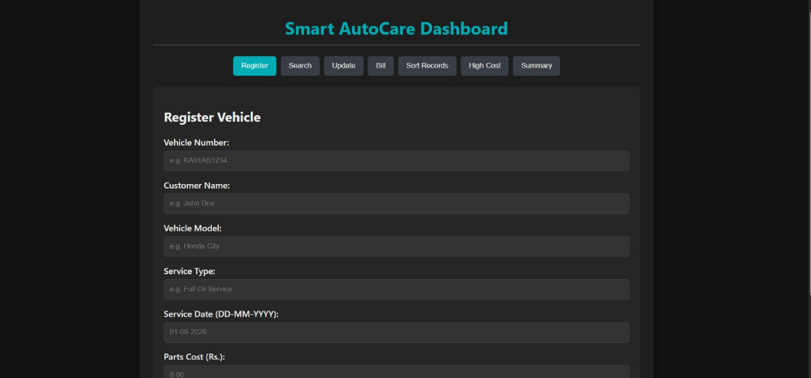
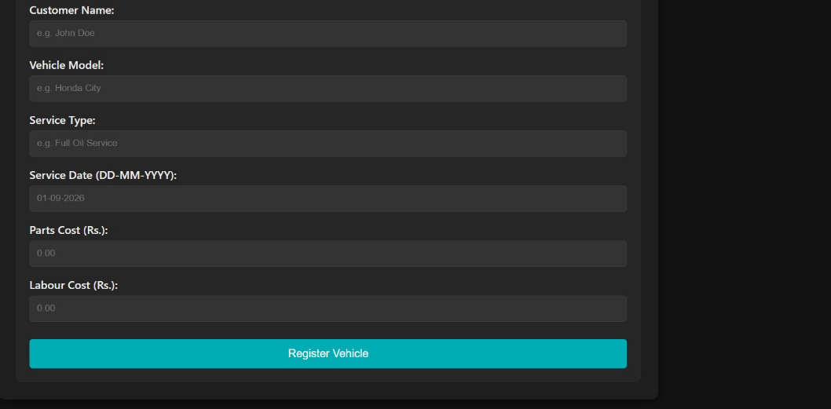

Conclusion
The Automobile Service Centre Management System provides an effective computerized solution for maintaining vehicle service records and managing service-related information. The application successfully implements all major requirements of the assignment, including vehicle registration, vehicle searching, service-detail updating, total bill calculation, service-cost sorting, high-cost service identification, daily service summaries, file storage, and loading of previous records.
The project demonstrates the practical application of structures and pointers in C. Structures provide an organized representation of service records, while pointers allow functions to efficiently calculate and modify record information. Searching and sorting algorithms provide mechanisms for accessing and organizing the stored records. File handling provides permanent storage and ensures that previously entered records can be recovered when the program is restarted.
The inclusion of input validation and runtime-error handling makes the application more reliable. Duplicate vehicle numbers, invalid costs, incorrect dates, maximum record capacity, invalid menu choices, file-opening problems, and incomplete file data are handled without causing uncontrolled program termination. The system therefore demonstrates not only the implementation of required functionality but also the importance of reliability and defensive programming.
Bubble sort was selected because of its simplicity and suitability for the limited number of records supported by the current system. However, the analysis shows that more efficient sorting algorithms should be considered if the application is scaled to a large automobile service centre. Overall, the project successfully satisfies the functional and technical requirements and provides a strong foundation for developing a more advanced automobile service-management system in the future.

References
- Sharma, S. (2021). Block-2: Functions, Structures, Pointers and File Handling in C. IGNOU.
- Mailund, T. (2021). Pointers in C Programming. Apress/Springer.
- Deitel, P., & Deitel, H. (2022). C: How to Program, 9th Edition. Pearson.
- Thareja, R. (2023). Programming in C, 3rd Edition. Oxford University Press.
- ISO/IEC. (2024). ISO/IEC 9899:2024 – Information Technology — Programming Languages — C.
- GNU Project. (2026). GCC Online Documentation. GNU Compiler Collection.



SIMATS ENGINEERING

Saveetha Institute of Medical and Technical Sciences
Chennai- 602105

Student Name: Palaseri Deekshitha
Reg. No: 192412104
Course Code and Name: CSA0208 C-Programming
Course Faculty: Dr. V.Jayasudha
Project Title: Smart AutoCare: A C-Based Vehicle Service and Billing Management System
Team contribution:
1. Abhidhya Sri (192520051)
2. P. Deekshitha (192412104)

Project Description
Smart AutoCare: A C-Based Vehicle Service and Billing Management System is a menu-driven C application designed to replace the traditional manual service-register system of an automobile service centre. The system maintains customer and vehicle service records, calculates service bills, searches and updates records, sorts vehicles based on service cost, generates daily service summaries, and stores records using file handling. Structures, pointers, arrays, functions, sorting techniques, and file operations are used to make the system organized and efficient.
My Contribution
Vehicle Record & Billing Module
I was responsible for developing the core vehicle service record and billing module of the Smart AutoCare system. I designed the structure to store vehicle number, customer name, vehicle model, service type, service date, parts cost, labour cost, and total service cost. I implemented vehicle registration, vehicle searching, updating of service details, and total bill calculation using pointers to structures. I also implemented input validation to handle duplicate vehicle numbers, negative costs, invalid service dates, and maximum record capacity. Finally, I integrated these functions with the menu-driven program and tested the basic vehicle service operations.



SIMATS ENGINEERING

Saveetha Institute of Medical and Technical Sciences
Chennai- 602105

Student Name: Abhidhya Sri
Reg. No: 192520051
Course Code and Name: CSA0208 C-Programming
Course Faculty: Dr. V.Jayasudha
Project Title: Smart AutoCare: A C-Based Vehicle Service and Billing Management System
Team contribution:
1. Abhidhya Sri (192520051)
2. P. Deekshitha (192412104)

Project Description
Smart AutoCare: A C-Based Vehicle Service and Billing Management System is a menu-driven C application designed to replace the traditional manual service-register system of an automobile service centre. The system maintains customer and vehicle service records, calculates service bills, searches and updates records, sorts vehicles based on service cost, generates daily service summaries, and stores records using file handling. Structures, pointers, arrays, functions, sorting techniques, and file operations are used to make the system organized and efficient.
My Contribution
Data Processing & File Management Module
I was responsible for developing the data processing, reporting, and file management features of the Smart AutoCare system. I implemented sorting of vehicles based on service cost using the Bubble Sort algorithm, displayed vehicles exceeding a specified service cost, and generated daily service summaries. I also developed the file-handling functions to save service records and load previous records when the program starts. I implemented error-handling mechanisms for file access, invalid data, and array capacity issues. In addition, I prepared and tested normal service, high-cost service, duplicate record, and invalid-input scenarios and contributed to the final integration and testing of the complete C application.

